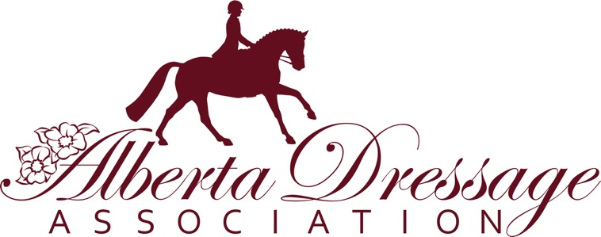

Funding for Non-Area Group Hosted 2021 Dressage Shows

The Alberta Dressage Association will consider requests for funds to support Non-Area Group Hosted Dressage Shows in 2021.

A Non-Area Group hosted show is one that is organized by a group or individual outside of one of the Alberta Dressage Association umbrella area groups – CC/ADA, CA/ADA, PA/ADA, EA/ADA, CL/ADA, JRYR/ADA and PR/ADA.

Following are specific details regarding the application process:
- Non-ADA area group hosted shows may request funds to support payment of
judges.
- The Show Manager must be a member of one of the ADA area groups.
- Requests for funds must be on the form below.
- Approved funds will be distributed as appropriate and fiscally manageable by ADA. The 2021 budget is set at a total of $2500.
- Requests must be submitted prior to April 30, 2021. Applications will be reviewed ASAP in early May with notification to the requestee.
- If you are planning more than one show, each Show must be submitted separately.
- On Approval, funds will be paid directly to the appropriate recipient (ie. the judge). Judges will be paid directly. ADA must receive an invoice from the organizer that includes the judge’s name prior to distributing funds.
- Funds will be paid in Canadian $$ only.

Send your application to: ada@albertadressage.com
If ADA approves your funding request, email the Judge Invoice to:
ADATreasurer@gmail.com
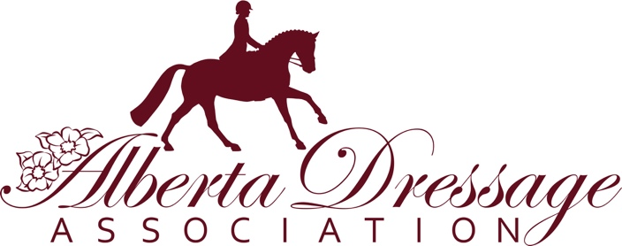

Non-Area Group Show Funding Request Form 2021

Submission Date
Organizer’s Name
Name of Show
Date(s) of Show
Level of Show
(Gold, Bronze, Wildrose, etc)
$$ Funds Requested
Description and details for use of Funds (include Name of Judge, mailing address for show)

Contact for Show (Show Manager): | Email:
Area Group Membership: | Phone:

